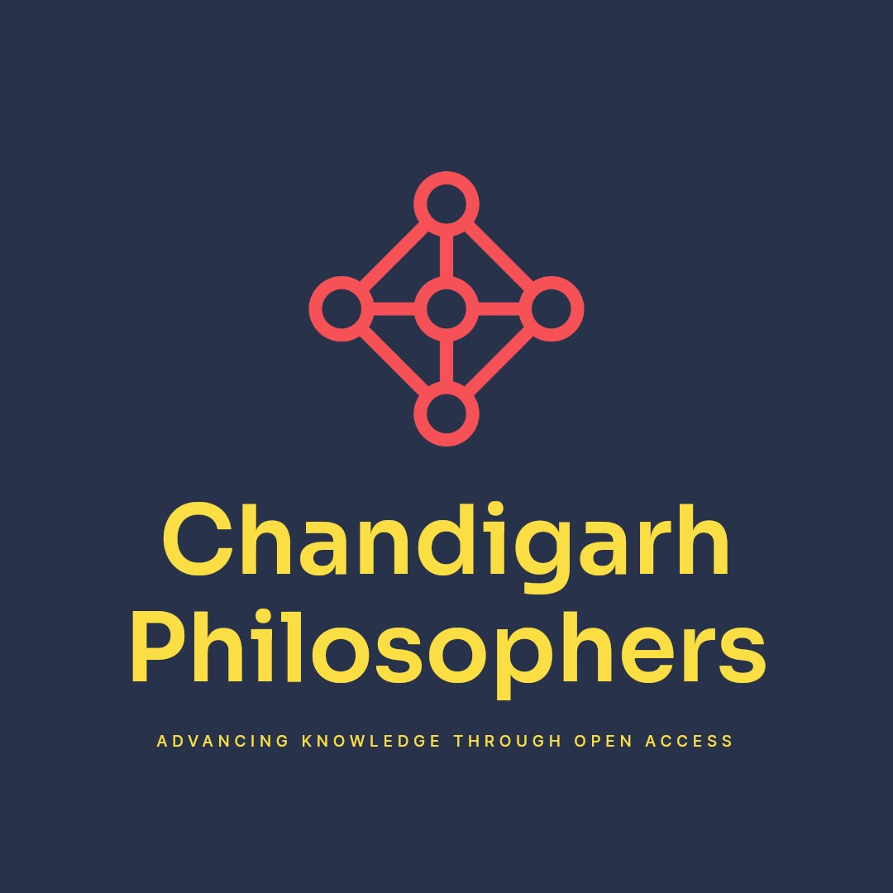
Chandigarh Philosophers
The Board of

INTERNATIONAL JOURNAL FOR MULTIDIMENSIONAL RESEARCH PERSPECTIVE (IJMRP)
An International Open Access, Peer Reviewed, Multidisciplinary, Refereed Journal
ISSN: 2584-0029
is hereby awarding this

certificate of publication

to

Dr.T. MILTON

In recognition of the paper entitled

Artificial Intelligence in Tourism-A review of Trends Opportunities and Challenges

Published in IJMRP
Vol-1 Issue-2,
Date of Publication 10.10.2023
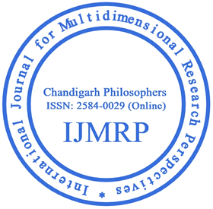
0

Paper id: 1270 Editor-in-Chief
Manage by: Chandigarh Philosophers
www.chandigarhphilosophers.com
Email id:info@chandigarhphilosophers.com

